DGFI User Manual

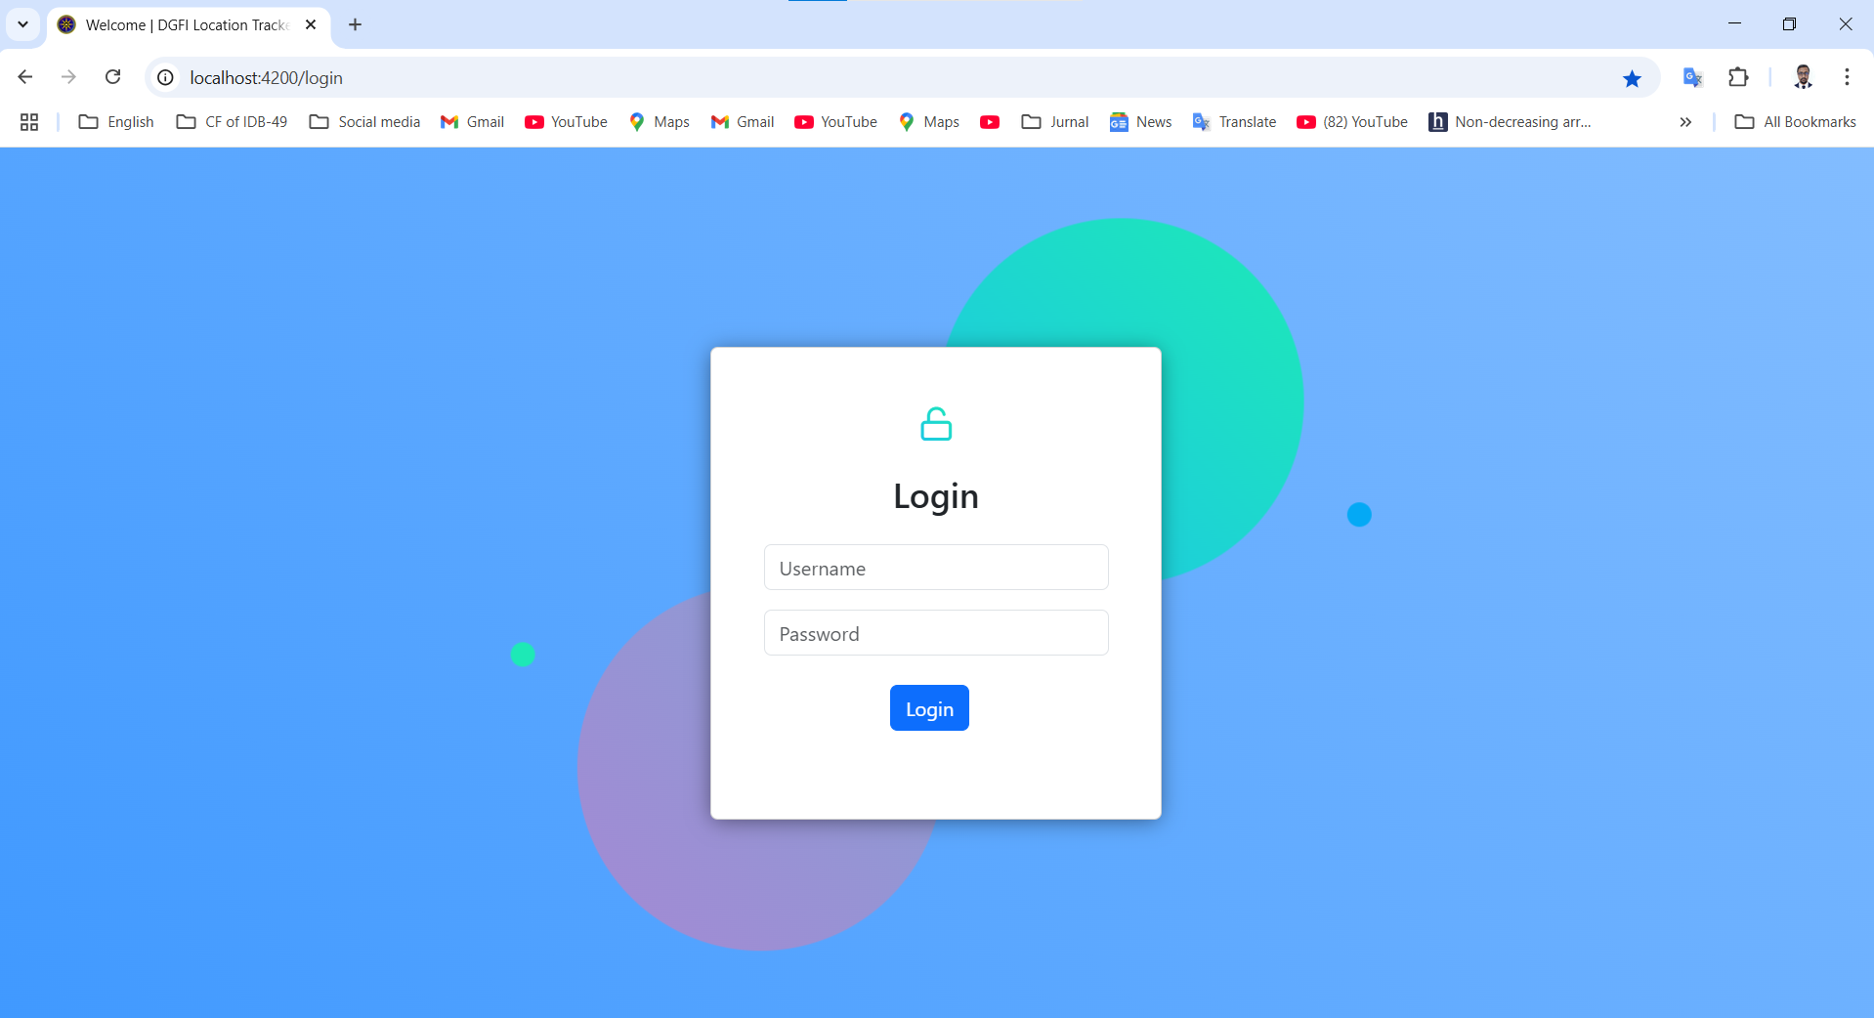

Login page:

Login with your username and password.

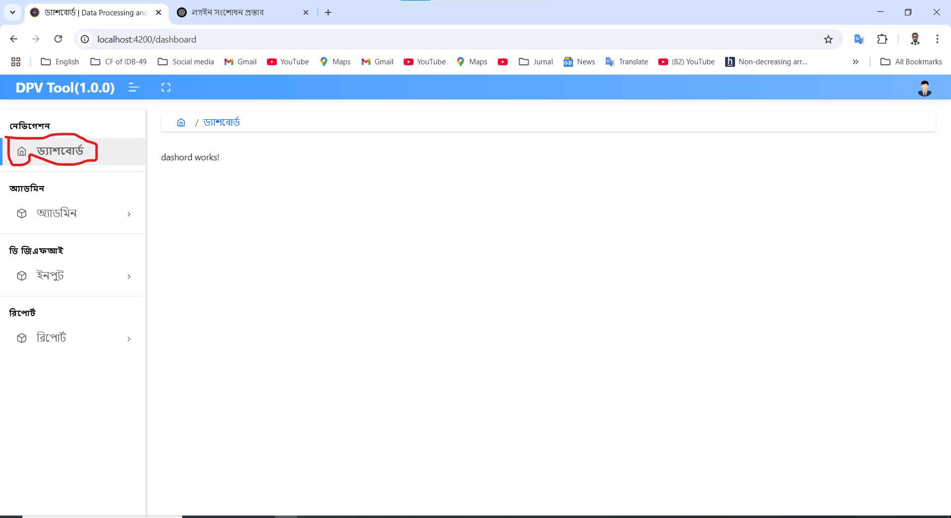

Dashboard:

Assign role permission ways user is getting this dashboard.

**Activity :**

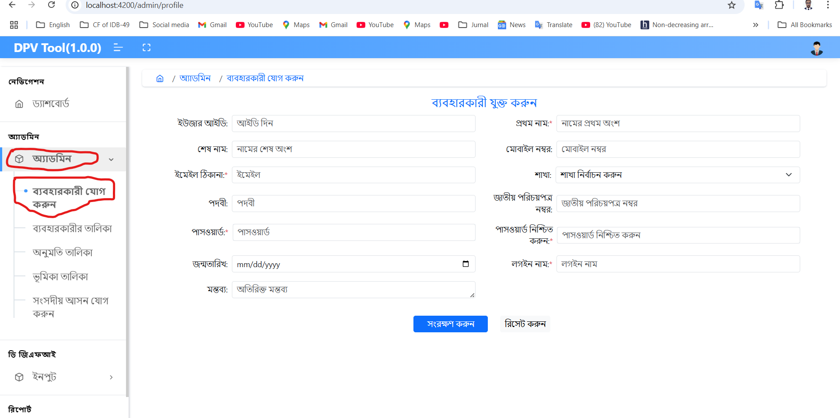

**Add User:**  
This option is used to add a new user under the Admin menu.  
After filling out the form, click the **Submit** button to save the user

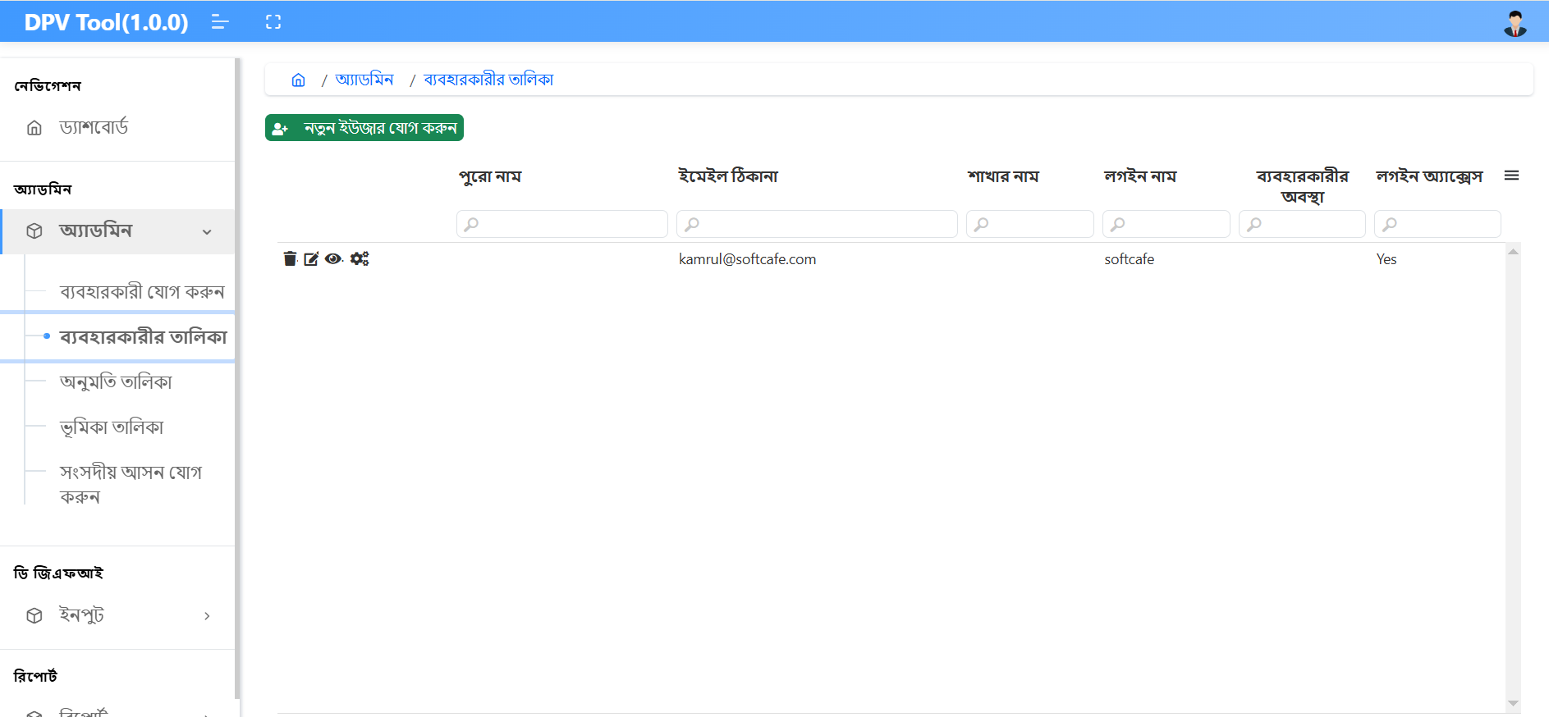

**User List:**  
This option is available under the Admin menu.  
It displays the list of all users.

* Click the **Edit** icon to modify any user information.
* Click **View** to see detailed information of a user.
* Click **Delete** to remove a user from the system.
* Click the **Manage Role** icon to assign roles to the user.

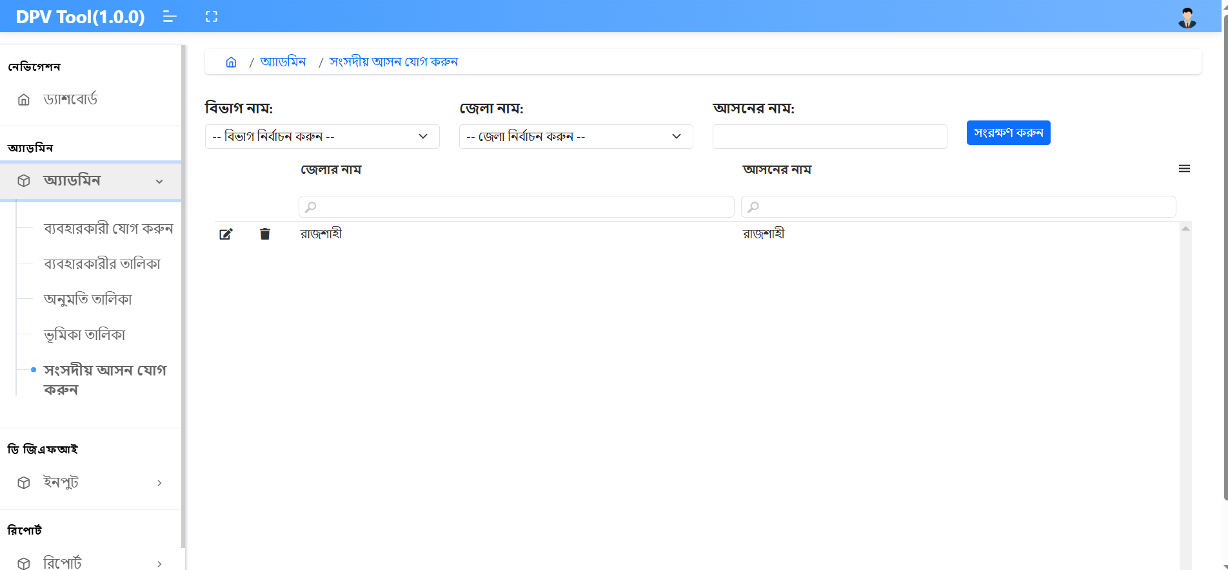

**Songsodiyo Ason Add:**  
This option is available under the Admin menu.  
To add a new parliamentary seat:

* First, select the **Division Name** and **District Name**.
* Then, enter the **Seat (Ason) Name**.
* Click the **Submit** button to save the new seat.
* Click **Edit** to modify an existing seat.
* Click **Delete** to remove a seat from the list.

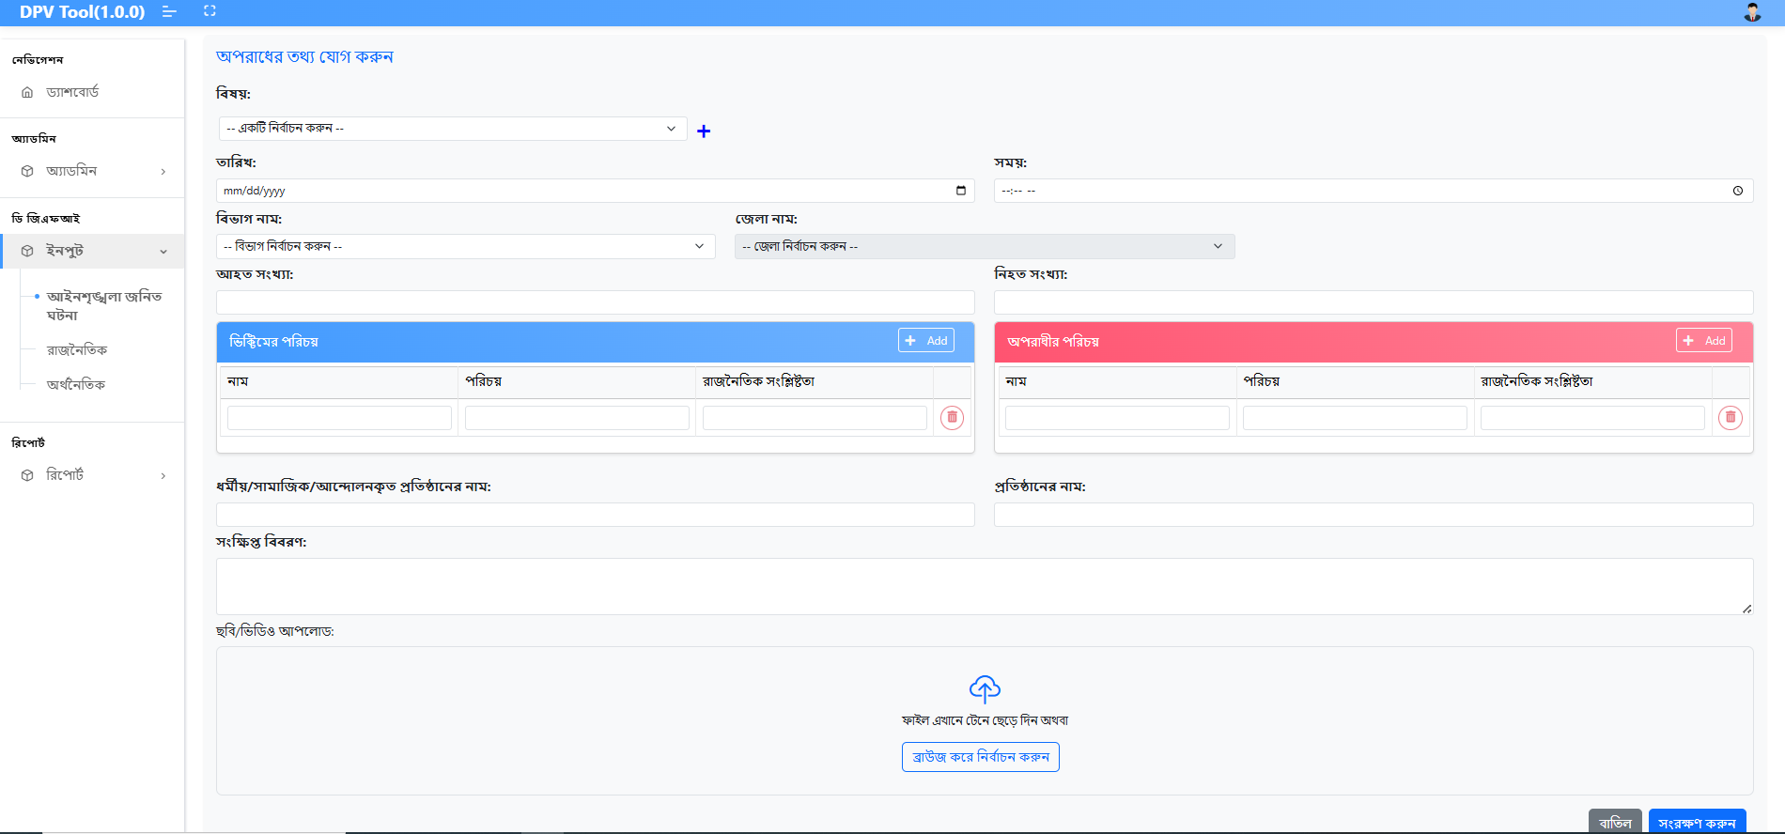

**Law and Order Incidents:**  
Click on the input bar under the **DGFI and Add** section.  
From the **Law and Order Incidents** menu:

* Select the **Subject**.
* Upload or input all related files.
* Then click the **Submit** button to save the information.

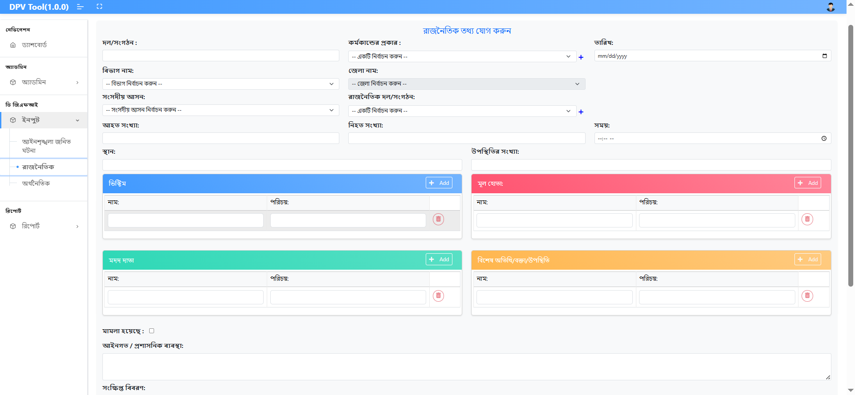

**Political (Under DGFI and Add):**  
Click on the input bar under the **DGFI and Add** section.  
From the **Political** menu:

* Input necessary information and select/upload all related files.
* Then click the **Submit** button to save the data.

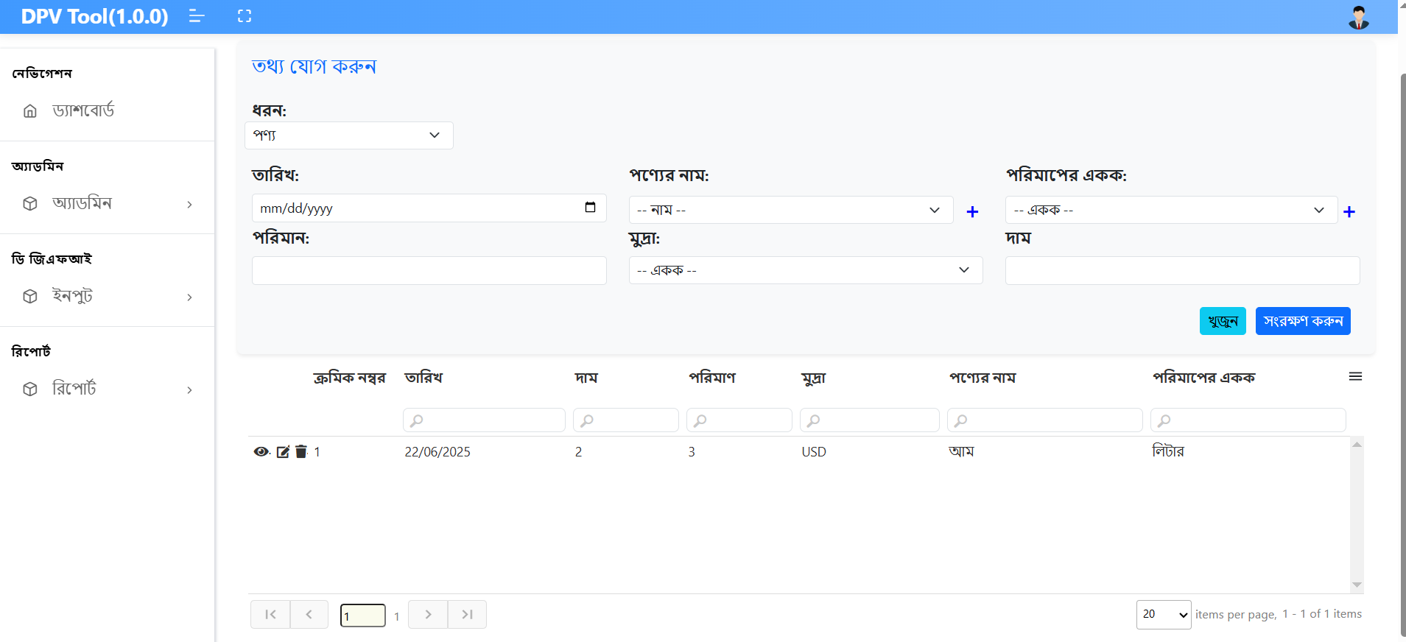

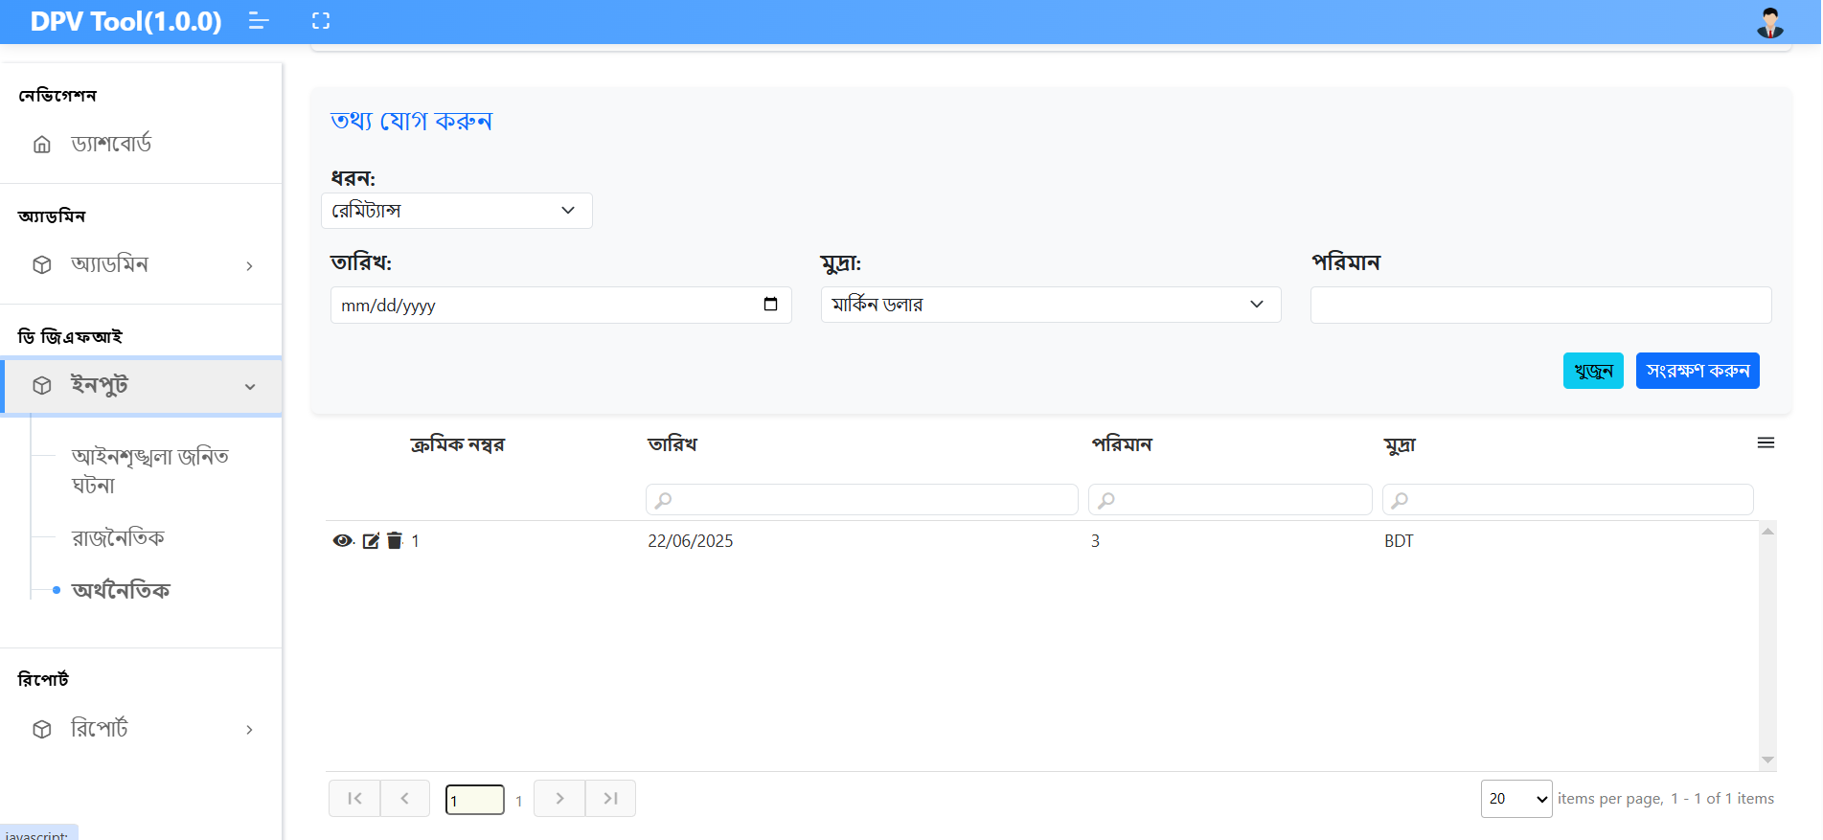

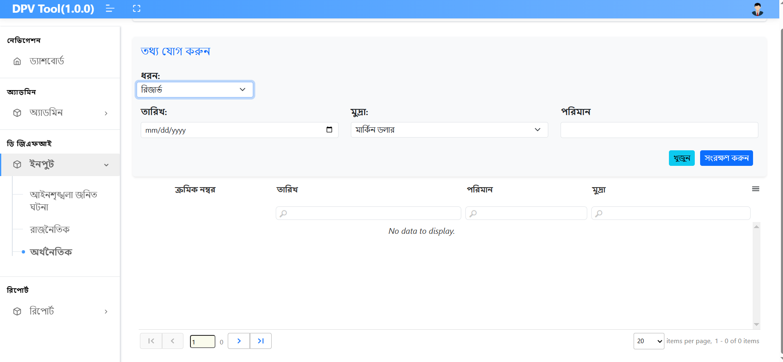

**Economic (Under DGFI > Input Menu):**  
To add economic information:

1. First, select the **Type**. Based on the selection, the full form will be displayed.
2. Then, input all necessary fields.
3. Click the **Submit** button to save the data.

Below the form, a list of submitted entries will be shown.

* Click **Edit** to modify existing data.
* Click **View** to see detailed information.
* Click **Delete** to remove an entry

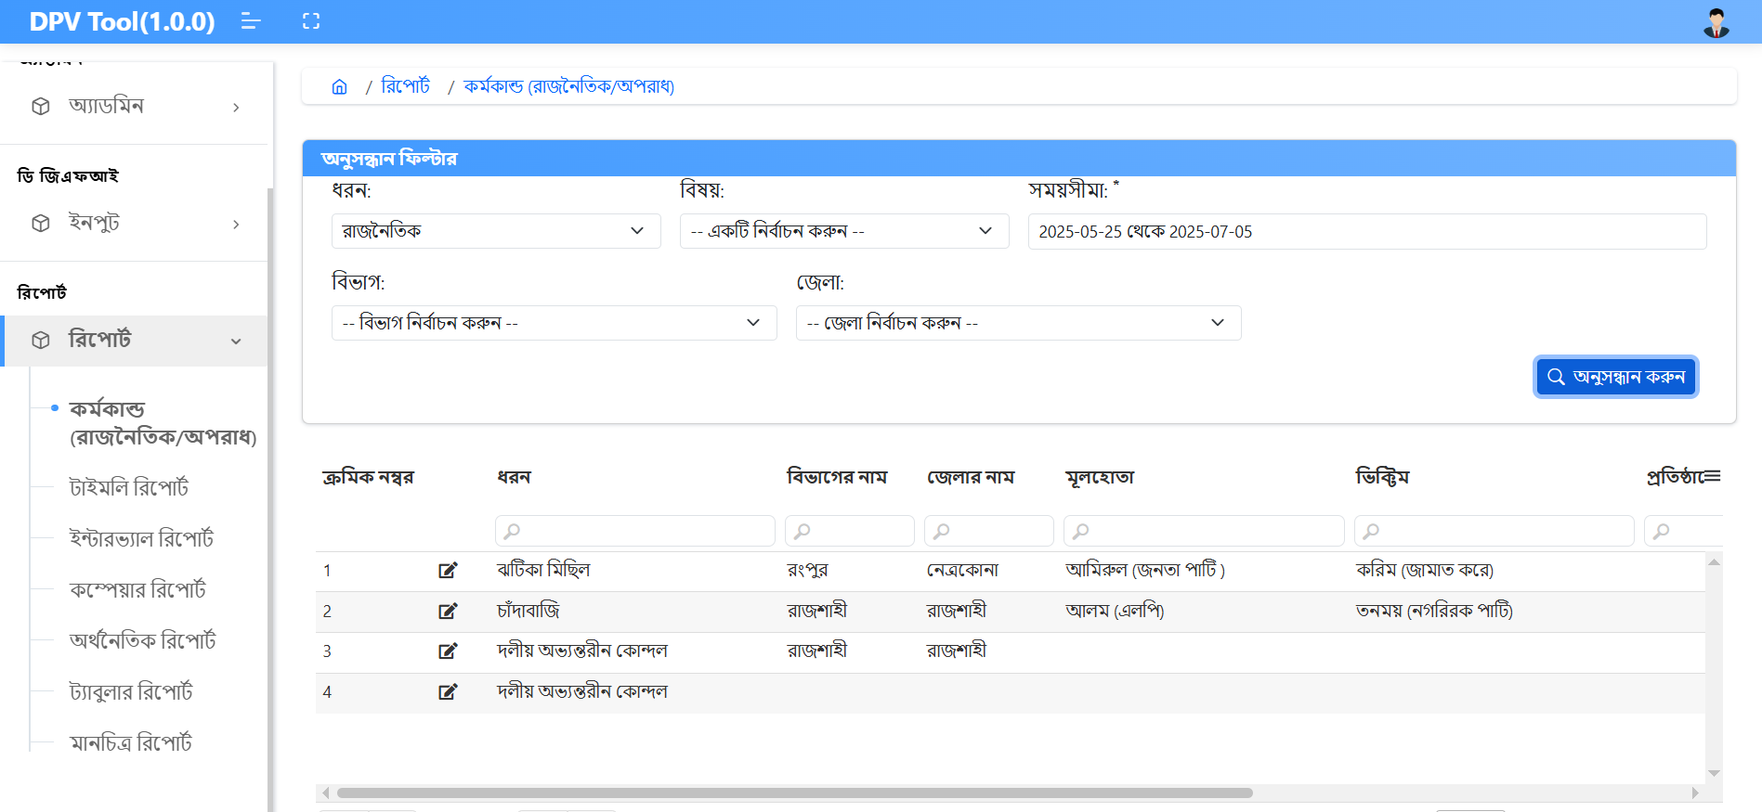

**Activity (Political/Crime) – Under Report Menu:**  
To view political or crime activity reports:

1. Click on **Activity Political/Crime** under the **Report** menu.
2. First, select the **Type** (either *Political* or *Crime*).
3. Then select the **Subject**, **Duration**, **Division**, and **District**.
4. Click the **Search** button to display the data.

The result list will be shown below the search section.

* Click **Edit** to modify any data.

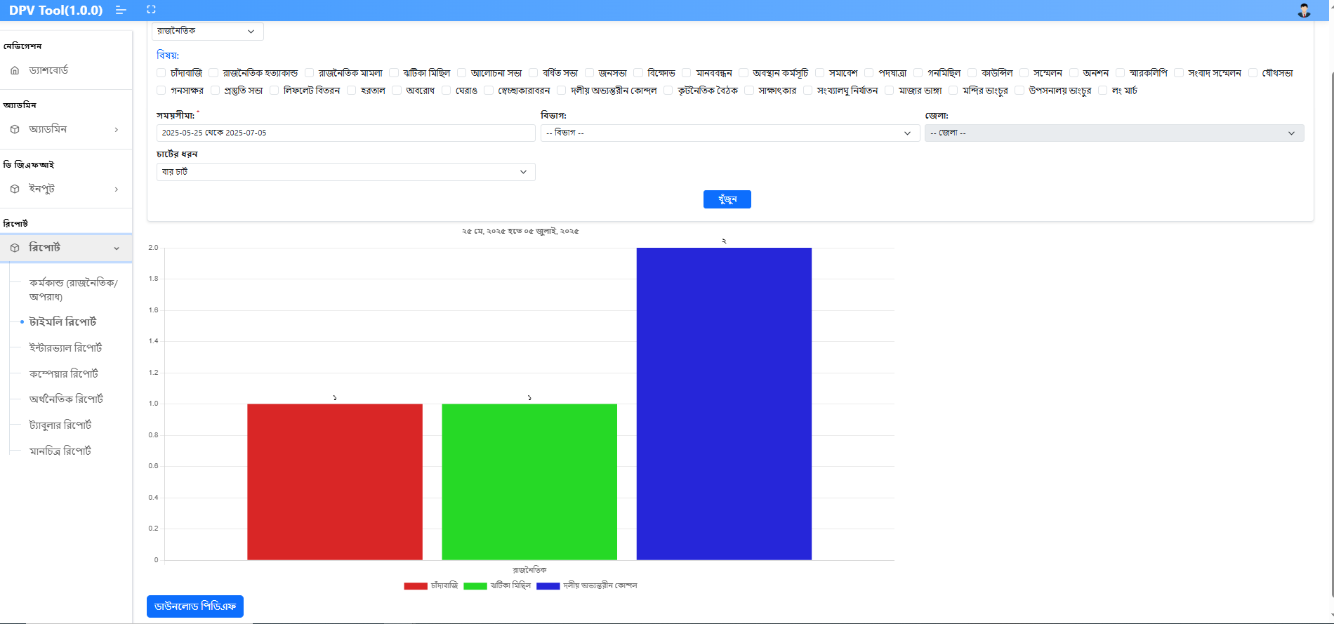

**Timely Report – Under Report Menu:**  
To generate and view a timely report:

1. Click on **Timely Report** under the **Report** menu.
2. Select the **Type**.
3. Choose one or multiple **Subjects**.
4. Select the **Duration**, **Division**, and **District**.
5. Choose how you want to display the result: **Bar Chart**, **Pie Chart**, or **Line Chart**.
6. Click the **Search** button to generate the report.
7. The result will be displayed below the search section based on the selected chart type.
8. Click **Download** to download the report.

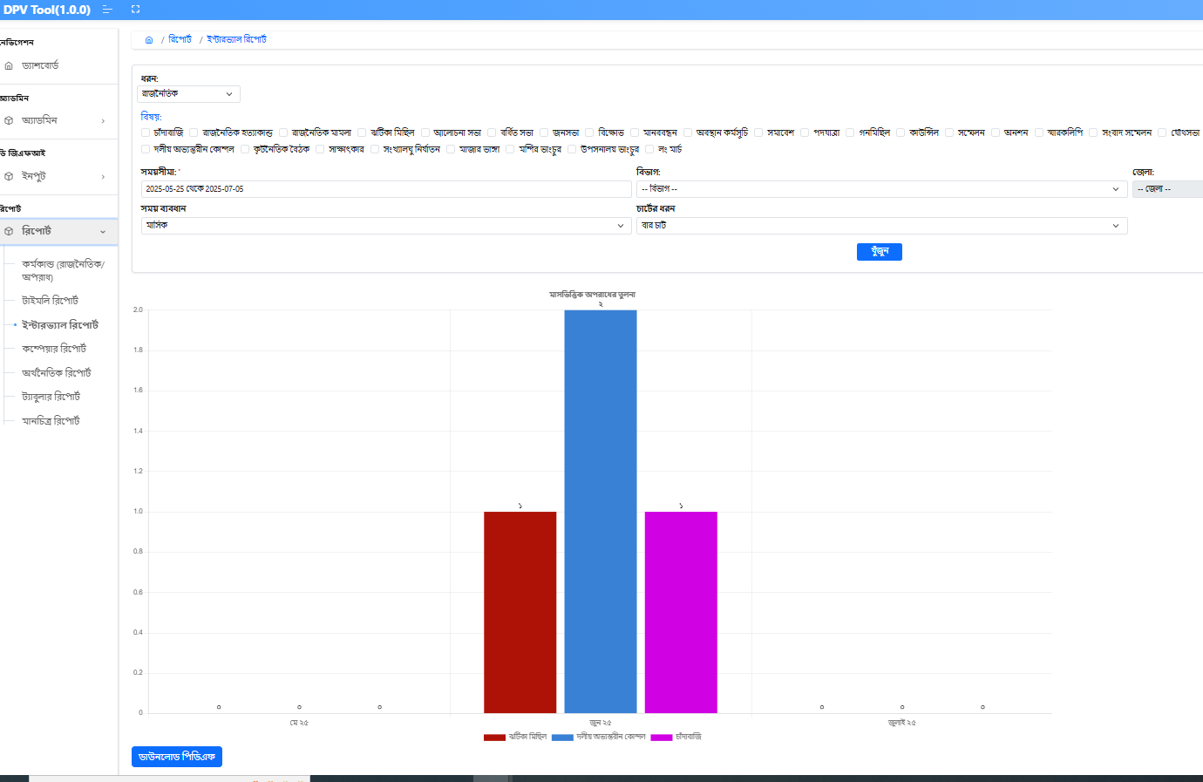

**Intervally Report – Under Report Menu:**  
To generate and view an intervally report:

1. Click on **Intervally Report** under the **Report** menu.
2. Select the **Type**.
3. Choose one or multiple **Subjects**.
4. Select the **Duration**, **Division**, and **District**.
5. Select the **Time Distance** (either Monthly or Yearly).
6. Choose how you want to display the result: **Bar Chart**, **Pie Chart**, or **Line Chart**.
7. Click the **Search** button to generate the report.
8. The result will be displayed below the search section based on the selected chart type.
9. Click **Download** to download the report.

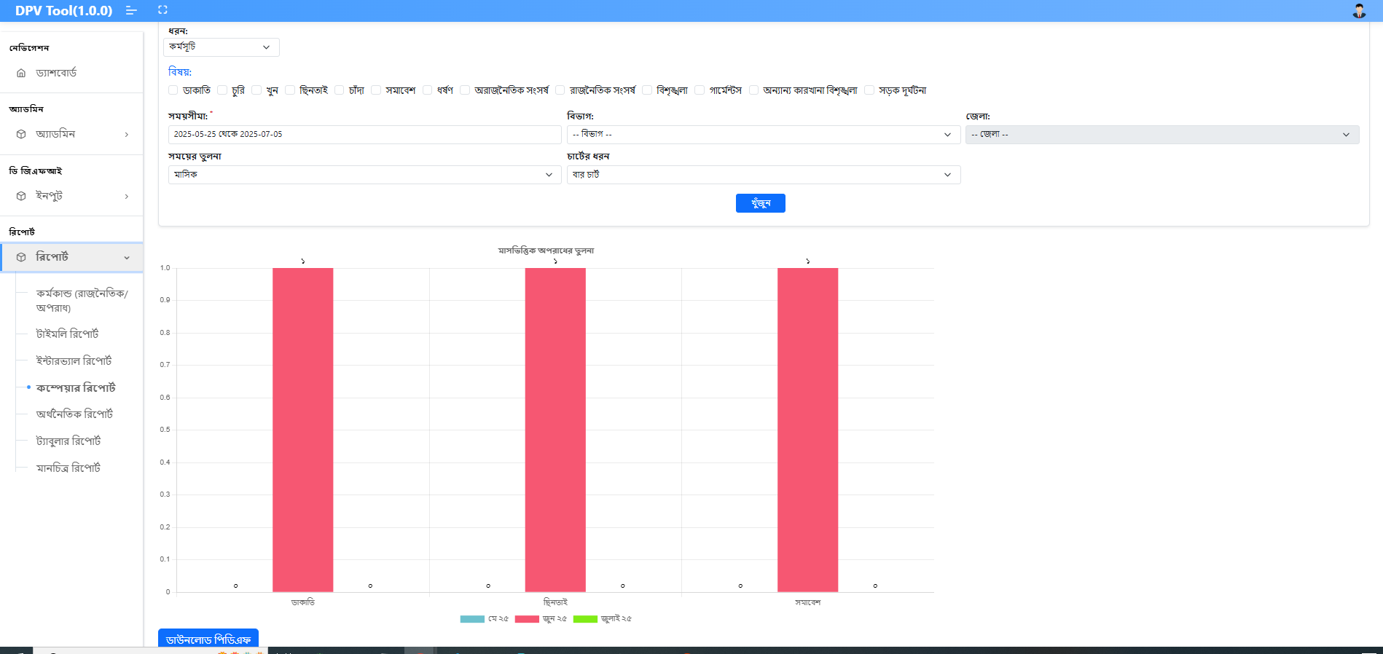

**Compare Report – Under Report Menu:**  
To generate and view a compare report:

1. Click on **Compare Report** under the **Report** menu.
2. Select the **Type**.
3. Choose one or multiple **Subjects**.
4. Select the **Duration**, **Division**, and **District**.
5. Select the **Time Distance** (either *Masik* – Monthly or *Barsik* – Yearly).
6. Choose how you want to display the result: **Bar Chart**, **Pie Chart**, or **Line Chart**.
7. Click the **Search** button to generate the report.
8. The result will be displayed below the search section based on the selected chart type.
9. Click **Download** to download the report.

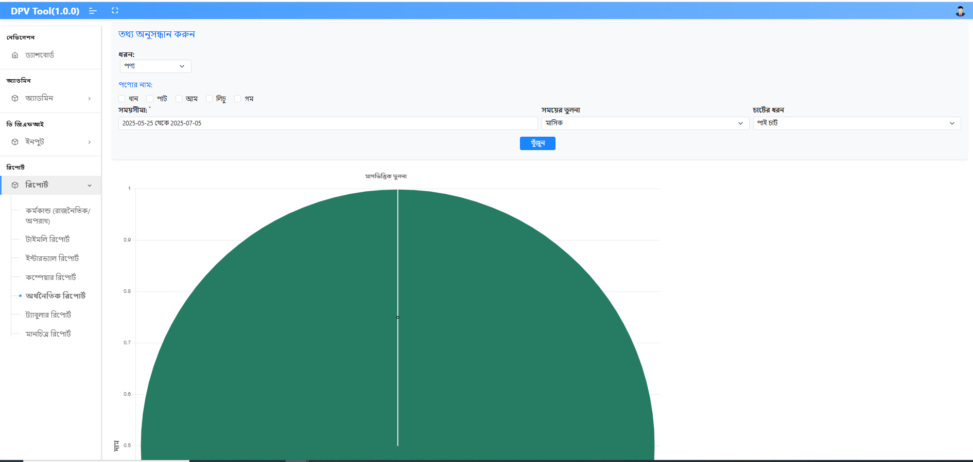

**Economic Report – Under Report Menu:**  
To generate and view an economic report:

1. Click on **Economic Report** under the **Report** menu.
2. First, select the **Type**.
3. Then select the **Time Period**.
4. Choose how you want to display the result: **Bar Chart**, **Pie Chart**, or **Line Chart**.
5. Click the **Search** button to generate the report.
6. The result will be displayed below the search section based on the selected chart type.
7. Click **Download** to download the report.

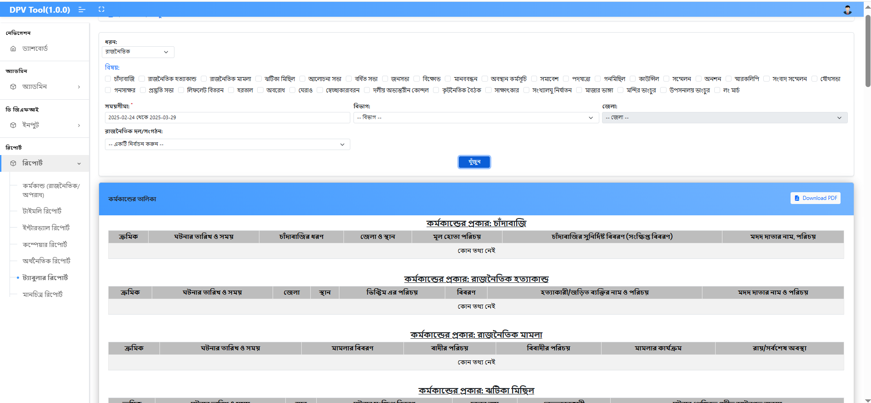

**Tabular Report – Under Report Menu:**  
To generate and view a tabular report:

1. Click on **Tabular Report** under the **Report** menu.
2. First, select the **Type**.
3. Then select **Political** under the **Subject** dropdown.
4. Choose the **Time Distance** (e.g., Monthly or Yearly).
5. The report will display all relevant data in tabular format based on the selected criteria.
6. Click **Download** to download the report.

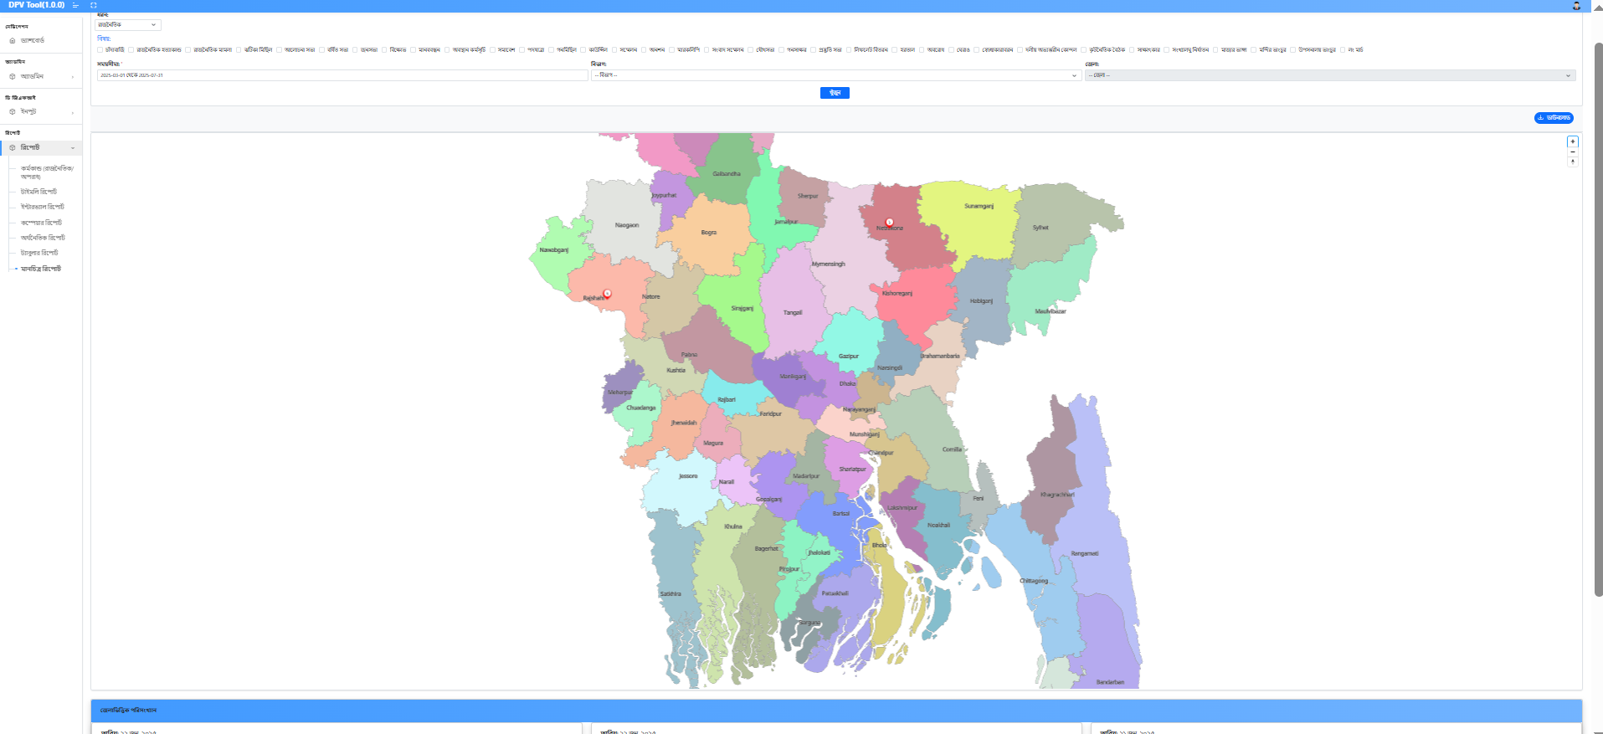

**Map Report – Under Report Menu:**  
To generate and view a map-based report:

1. Click on **Map Report** under the **Report** menu.
2. First, select the **Type**.
3. Then select one or multiple **Subjects**.
4. Choose the **Duration**, **Division**, and **District**.
5. The report will display all relevant data on the map based on the selected criteria.
6. Click **Download** to download the report.

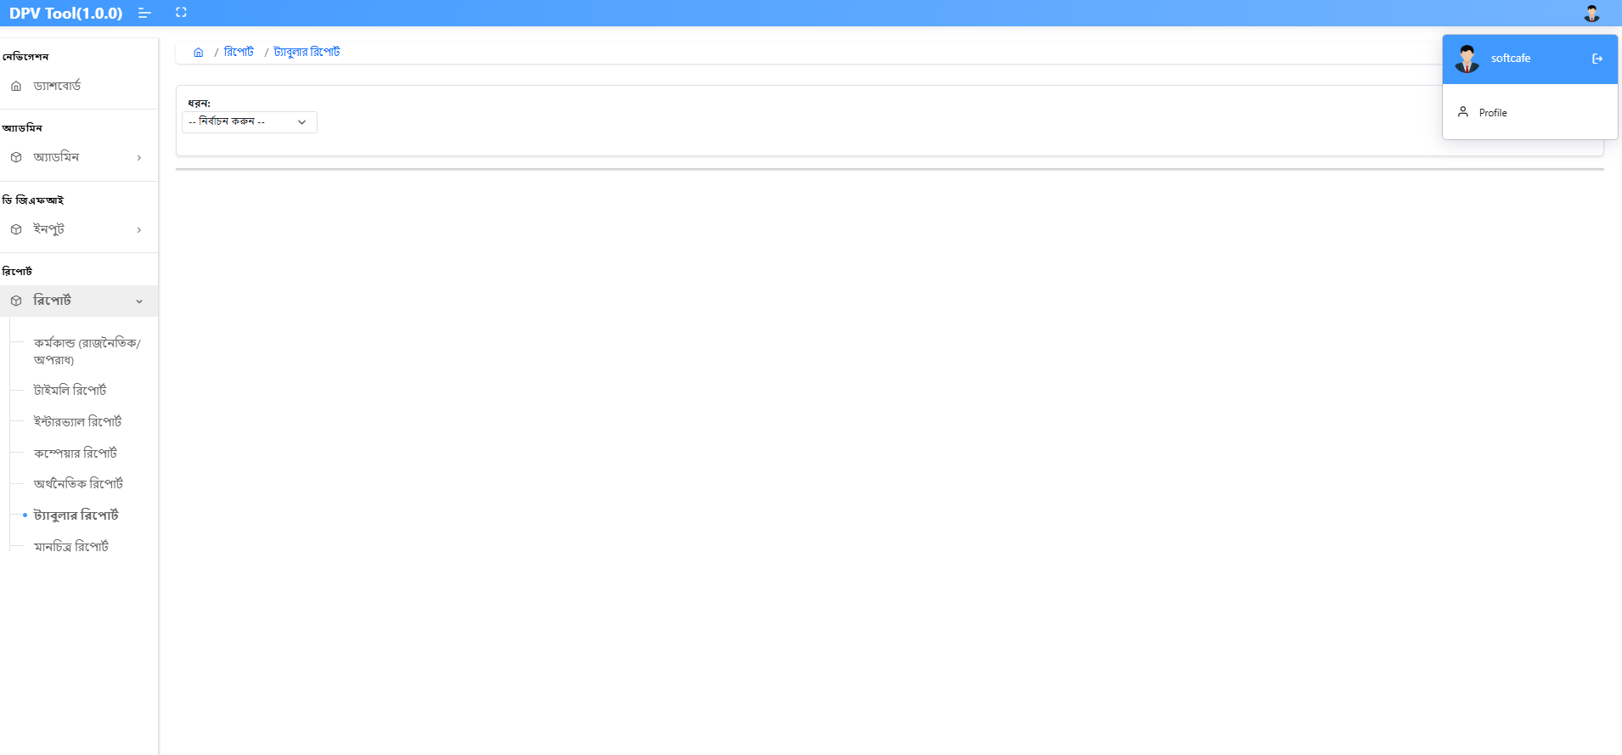

**Logout:**  
Click on the **Logout** icon located at the top-right corner of the screen to log out from the application.